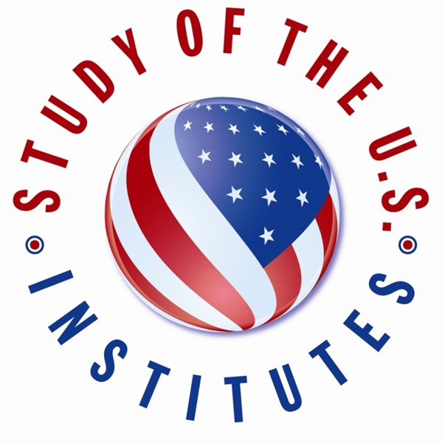
Study of the U.S. Institutes (SUSIs)
for Student Leaders

We are pleased to invite candidate nominations for summer 2022 Study of the U.S. Institutes (SUSIs) for Student Leaders on the topic of Environmental Issues. The five-week program will take place during the June to August timeframe in 2022; exact dates will be communicated at the time of selection. Should health, safety, and travel conditions continue to pose significant challenges, the program will pivot to a modified virtual format.

Study of the U.S. Institutes (SUSIs) for Student Leaders are intensive short-term academic programs whose purpose is to provide groups of undergraduate student leaders with a deeper understanding of the United States while simultaneously enhancing their leadership skills. Hosted by Michigan State University, this institute will provide participants with an overview of how citizens have shaped U.S. history, government, and society both as individuals and groups. Each Institute has 20 participants. The Institutes consist of a four-week academic residency with a balanced series of seminar discussions, readings, group presentations, and lectures. Academic sessions will be complemented with hands-on sessions or workshops designed to build skills in the topics mentioned above. The Institute will encourage participants to develop innovative and practical plans to become engaged citizens in their own communities. Site visits, leadership development, cultural activities, and community service complement the coursework and academic sessions. If conditions allow, the Institute will include a one-week integrated study tour in the United States. Note that if the program must take place virtually, participants will engage in similar activities but online from their home countries.

The Study of the U.S. Institute on Environmental Issues will provide participants with an overview of climate change along with its impact on communities in the American west, natural resources, and the local economy. Academic sessions will explore clean energy, sustainable development, the risks of natural disasters, and the intersection of climate justice and community activism. In order to enhance the academic experience, the Institute will focus on specific themes and sub-topics such as strategic communication, social justice, emergency response, water rights, energy efficiency and sustainability. Academic activities will be supplemented by opportunities to engage with the local community, meeting with local environmental non-profits, and a study tour to New Orleans, Louisiana. Should conditions allow, the SUSIs for Student Leaders from Europe will begin with an Opening Forum in Washington, D.C., bringing together participants in all three Institutes for networking, foundational leadership skills development, and exploring relevant topics from multi-regional perspectives.

Program Funding: Program will cover all participant costs, including program administration; international and visa travel, travel allowances, domestic travel and ground transportation; book, cultural, mailing and incidental allowances; and housing and subsistence.
Program Requirements and Restrictions: Candidates should be made aware that they are applying for an intensive and rigorous academic Institute and are expected to fully participate in all aspects of the program. Participants must attend all lectures, participate in all required organized activities and complete all assignments. Family members and/or friends may not accompany or join participants for any part of the program. Please make these requirements clear to all nominees.

English Language Ability: English Language proficiency is required to participate in this program. All candidates must be proficient in English so that they can actively participate in the academic program.

Housing and Meal Arrangements: Housing will be in shared or single university dorms on campus or full-service hotels within walking distance of most classroom activities. Male and female participants will be housed in separate quarters. In addition to regular group meals and a university meal plan, participants may have access to a kitchen to cook some meals on their own.
Care will be taken to ensure that any special requirements regarding diet, daily worship, housing, and medical care are satisfied. Should a participant need to quarantine due to positive COVID-19 test results, accommodations will follow Center for Disease Control (CDC) guidelines.

Health Benefits: All participants will receive the Department of State’s Accident and Sickness Program for Exchanges (ASPE) health benefit during the U.S.-based in-person Component.

Travel Policy: Under no circumstances are participants allowed to arrive in the United States prior to the start date of the SUSI or remain in the United States after the end date. Similarly, participants will not be permitted to leave the SUSI to visit relatives or friends while in the United States. If a relative or friend wishes to visit a participant, it will be considered on a case- by-case basis in consultation with the ECA program officer and the host institution. Participants are required to return to their home countries immediately following the end of the Institute.

Violations of program rules, host institution rules, or local, state or federal laws can be grounds for immediate dismissal from the program. It is important that these requirements and restrictions be made clear to all candidates before nominations are submitted.

The participants are expected to be highly motivated first through third year undergraduate students from colleges, universities, and other institutions of higher education, who demonstrate leadership through academic work, community involvement, and extracurricular activities.

Candidates nominated for this program should:
- be proficient in English;
- be interested in the Institute topic;
- be between 18 and 25 years of age;
- have at least one semester left of their undergraduate studies, and be committed to returning to their home universities following completion of the program;
- demonstrate strong leadership qualities and potential in their university and community activities;
- indicate a serious interest in learning about the United States;
- have a sustained high level of academic achievement, as indicated by grades, awards, and teacher recommendations;
- demonstrate commitment to community and extracurricular university activities;
- have little or no prior study or travel experience in the United States or elsewhere outside of Europe;
- be mature, responsible, independent, confident, open-minded, tolerant, thoughtful, and inquisitive;
- be willing and able to fully participate in an intensive academic program, community service, and educational travel;
- if the program is conducted in-person, be comfortable with campus life, prepared to share living accommodations, and able to make adjustments to cultural and social practices different from those of their home country; and,
- if the program is conducted virtually, posts/Fulbright commissions must ensure that participants have access to the internet and help facilitate such access if needed.

To apply, please complete the Application form. A very important part of the application is the Candidate Personal Statement, and thus it should be effective and competitive.

Looking forward to receiving your applications!

